[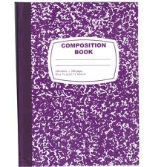](http://www.google.com/imgres?sa=X&biw=1440&bih=754&tbm=isch&tbnid=WEKuHLyA1MufFM:&imgrefurl=http://www.eclipsusa.com/product_info.php?products_id=535&osCsid=33fe3cf066..&docid=huTvQQpG6smIKM&imgurl=http://www.eclipsusa.com/images/01925.jpg&w=600&h=600&ei=QFGvUe7TCoSwyQGBvoDIDQ&zoom=1&ved=1t:3588,r:23,s:0,i:241&iact=rc&dur=1160&page=1&tbnh=196&tbnw=196&start=0&ndsp=24&tx=106&ty=98)**Supply List – Mrs. Mignogna - Third Grade**

Notebooks:

* One marble notebook – any color – at least 100 pages
* One – three subject spiral notebook – This will be your writer’s notebook. We will decorate this at school.
* Please send in a large Ziplock baggie with some/any of the following: (Theses items will be cut up and glued onto the notebook.) Family pictures, pictures of your child doing activities they love (swimming, skiing, riding horses, dancing, sports…), pictures from vacations, stickers, cut up items from magazines, anything they want to include that may stir up memories, help me get to know him/her, and help them write… The more the better and what they do not use can go back home.

Folders:

* + One of your choice to be used as your homework folder

Other items:

* + One magazine holder – The hard, plastic kind is the most durable.
  + Headphones for computer lab
  + One/two independent reading books
  + 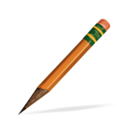Zippered pencil case with the following items:
    - C:\Users\kmignogna\AppData\Local\Microsoft\Windows\Temporary Internet Files\Content.IE5\HUAWZ2FR\MC900232760[1].wmfFive or more sharpened pencils
    - One blue and one red pen
    - One box of colored pencils
    - One box of crayons
  + Two/three glue sticks